Assignment - I

BlockChain Technology

Ganesh College Of Engineering

|  |  |
| --- | --- |
| Name | G.Gokul |
| PROJECT NAME: | VACCINE TRACKING-TRANSPARENT |
| TEAM ID | NM2023TMID00426 |
| COLLEGE | GANESH COLLEGE OF ENGINEERING |

Output :

Step 1 :

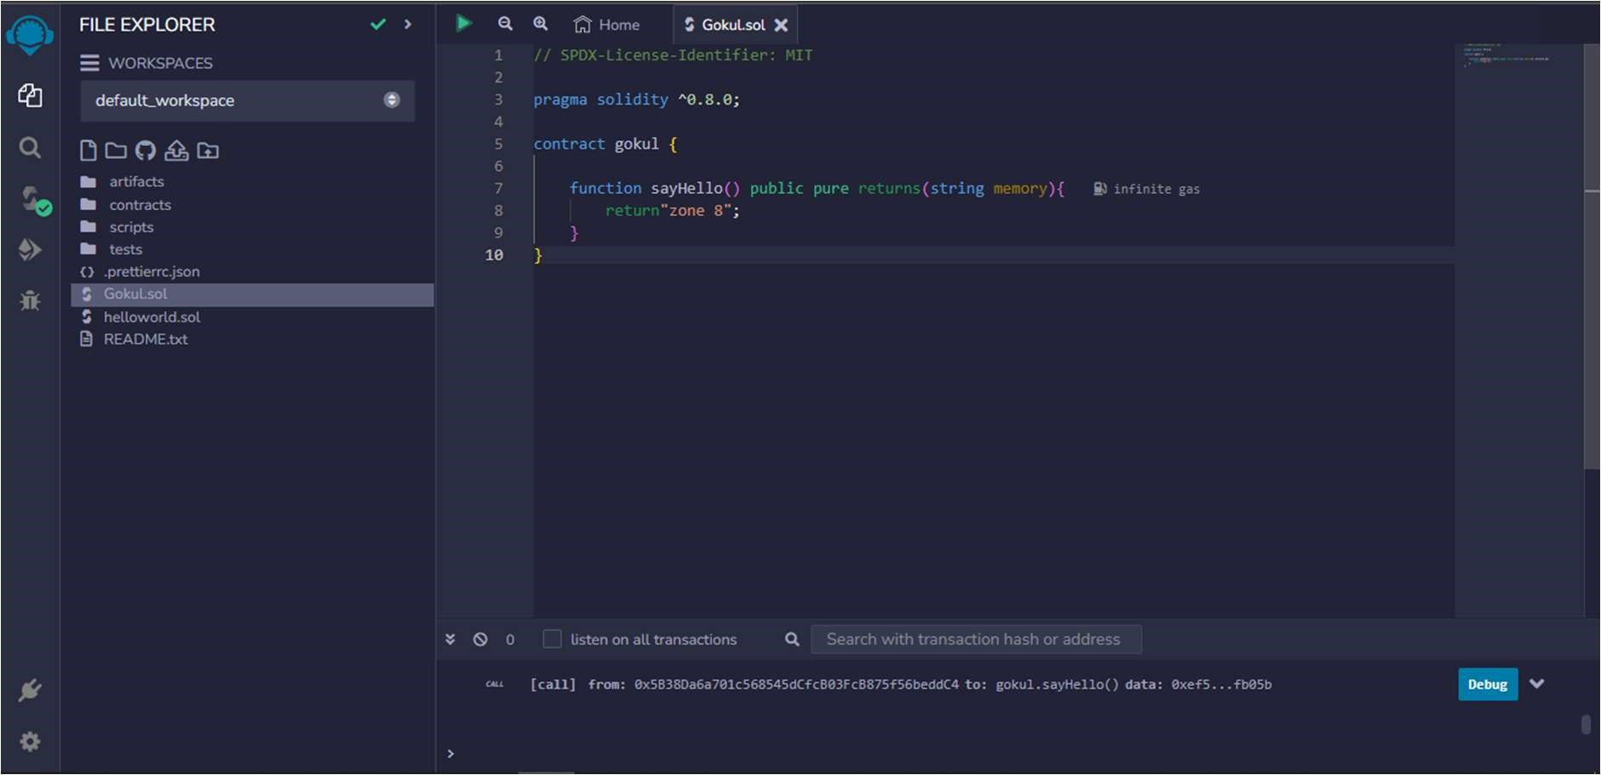

Step 2 :

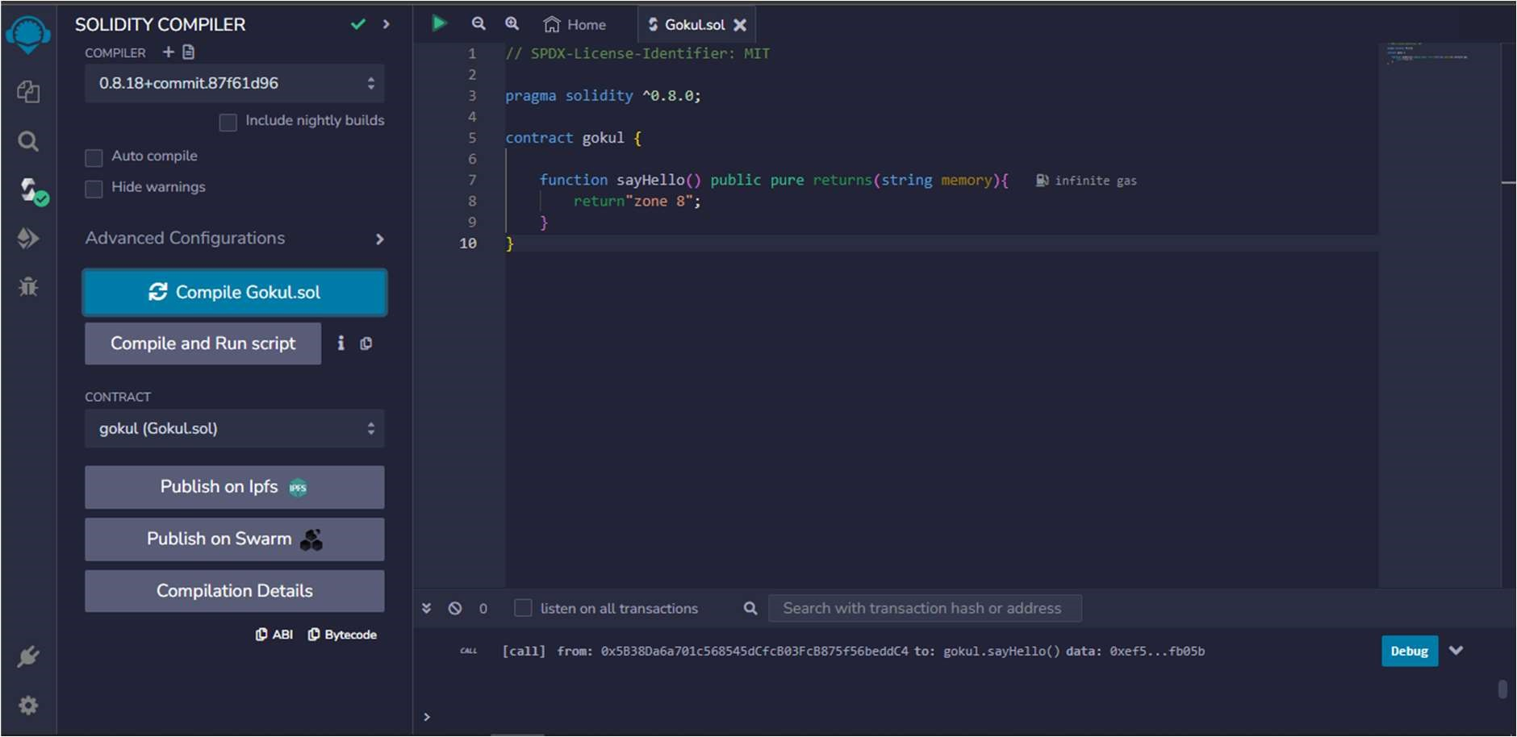

Step 3 :

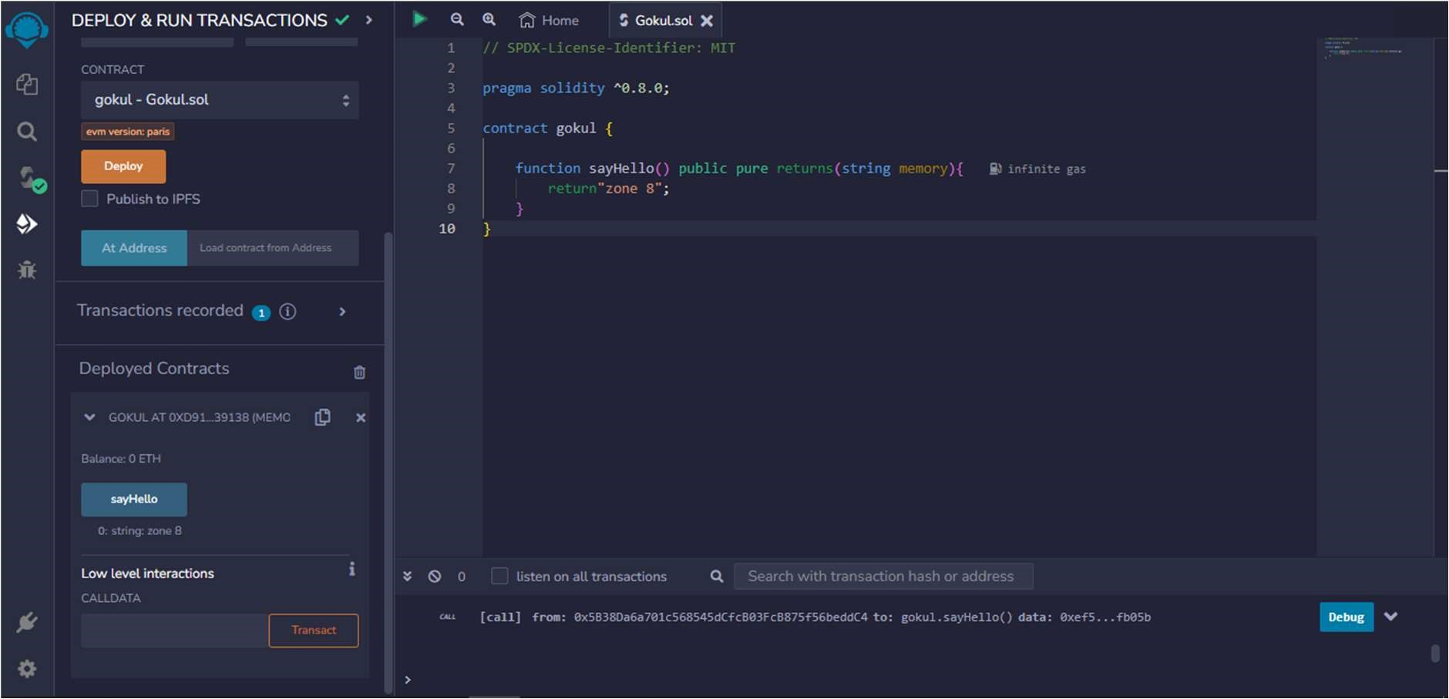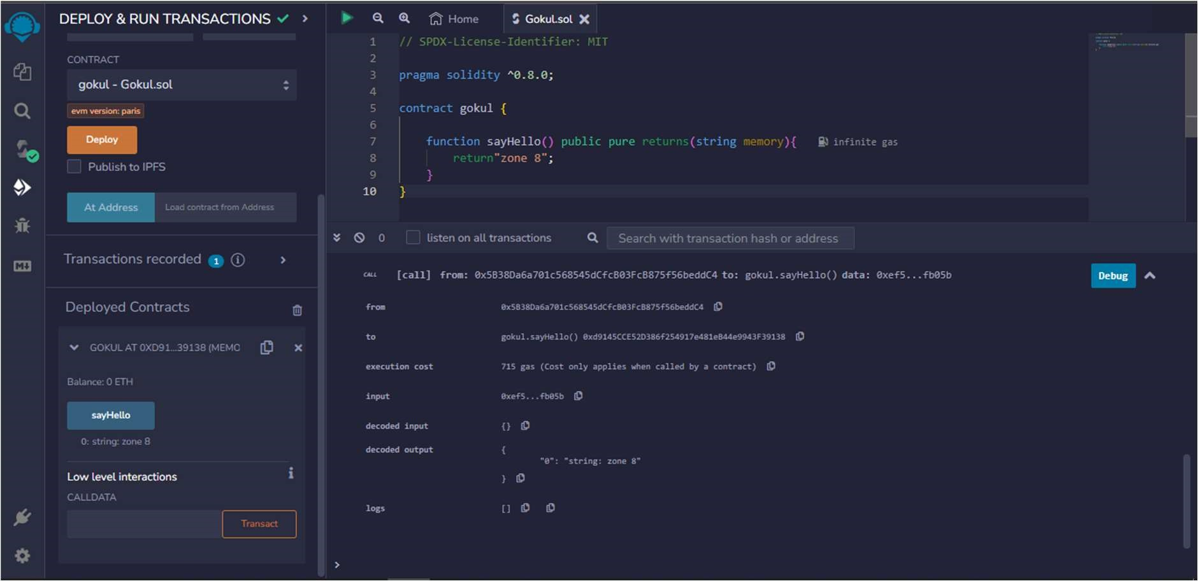

ABI :

[

{

"inputs": [],

"name": "sayHello",

"outputs": [

{

"internalType": "string",

"name": "",

"type": "string"

}

],

"stateMutability": "pure",

"type": "function"

}

]

Bytecode :

608060405234801561001057600080fd5b50610173806100206000396000f3fe608060405234801561

001057600080fd5b506004361061002b5760003560e01c8063ef5fb05b14610030575b600080fd5b61

003861004e565b604051610045919061011b565b60405180910390f35b60606040518060400160405

280600681526020017f7a6f6e65203800000000000000000000000000000000000000000000000000 00815250905090565b600081519050919050565b600082825260208201905092915050565b60005b

838110156100c55780820151818401526020810190506100aa565b60008484015250505050565b600

0601f19601f8301169050919050565b60006100ed8261008b565b6100f78185610096565b93506101

078185602086016100a7565b610110816100d1565b840191505092915050565b6000602082019050 818103600083015261013581846100e2565b90509291505056fea2646970667358221220bc9d72eb3 d398ab6f051889207e3d105a62e32be843e77f5b7c5383e894afd3164736f6c63430008120033